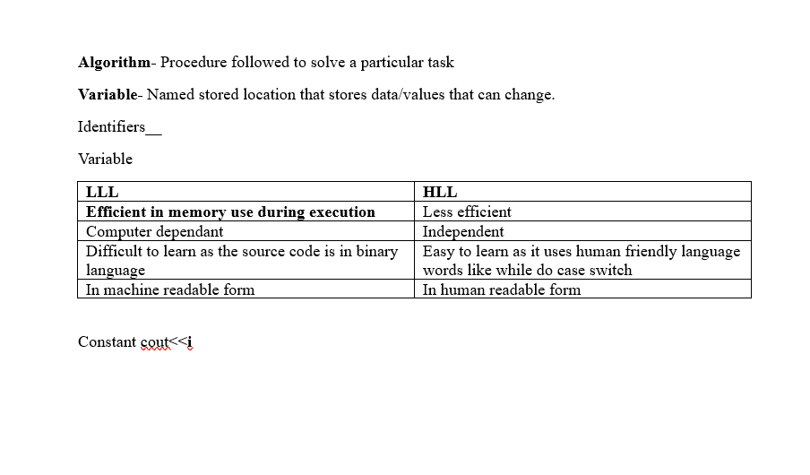

|  |  |
| --- | --- |
| **SYNTAX** | **LOGICAL** |
| Error as a result of not following rules of a given language of programming | Error in a programs source code that gives way to erroneous behaviour |
| Source code wont execute to completion | Source code will execute to completion |
| Easy to capture during compilation | Not easy to find as the program will execute successfully without any syntax error but  **wont get the desired output** |
|  |  |

comment

|  |  |
| --- | --- |
| Single //------------------ | Multi line /*------*/ |